Technical Progress Report: Vision Guard AI Intruder Detection System

(Day 1)

1. Project Identification and Scope
Vision Guard is an AI-driven, real-time intruder detection system engineered to provide automated surveillance and evidence acquisition. The primary objective for this development phase was to architect a functional software prototype capable of high-speed face detection, event-driven alerting, and deterministic image evidence capture.
Day 1 development focused on establishing a robust environment, engineering the core detection pipeline, and implementing localized storage logic to ensure a stable foundation for future embedded system integration.

2. Technical Environment and Configuration
We have standardized the development environment to ensure low-latency processing and reproducibility across localized workstations.

Core Technology Stack
Category | Tool/Technology | Purpose / Role
Programming Language | Python | Primary development language for rapid prototyping and CV integration.
Computer Vision Library | OpenCV | Leveraged for real-time video stream manipulation and Haar Cascade implementation.
Integrated Development Environment (IDE) | PyCharm | Utilized for debugging, version control, and environment management.

Environment Setup and Directory Architecture
To initialize the prototype, the following dependency was installed via the terminal: pip install opencv-python
The project follows a modular directory structure to maintain a clear separation between logic and generated data:
AI-EC-Project/
├── face_detection.py # Primary application logic and detection pipeline
├── captures/ # Local repository for event-driven image evidence
├── requirements.txt # Dependency manifest
└── README.md # Documentation and setup instructions

2.1 Library Integration

The system is deployed within a Python environment using the PyCharm IDE. The core image processing pipeline is powered by the OpenCV library. To ensure robust directory initialization and hardware interaction, the following standard libraries are integrated:

os: Utilized for directory and file I/O management. The architected solution uses os to verify the existence of the captures/ directory at runtime, creating it if necessary, to prevent file-system exceptions.

winsound: Manages the event-driven alert mechanism, interfacing with system audio drivers to provide immediate audible feedback during detection.

time: Essential for system state management, specifically regulating the intervals between detection events and enforcing the system's timing logic.

3. System Architecture and Workflow Analysis
The system operates on a linear, high-efficiency pipeline designed for real-time execution. We have synthesized the workflow into the following technical progression:
- Input (Automated Initialization): The system triggers the automated startup of the primary webcam to capture live video frames instantly upon execution.
- Processing (Dimensionality Reduction): Captured frames are converted to grayscale. This reduces the computational load from three color channels to one, optimizing the system for high-frame-rate analysis.
- Decision (Inference): The system leverages a Haar Cascade classifier to scan the processed frames for specific geometric patterns corresponding to human faces.
- Action (Event-Driven Trigger): Upon a positive detection, the system executes a dual-action trigger: it prints a real-time console alert and persists the current frame to local storage.
- Control (Resource Management): A software-level cooldown is applied to regulate capture frequency. Users can terminate the process via a manual interrupt.

4. Core Component Implementation Details

4.1. Detection Engine and Image Processing

The detection pipeline follows an "Input → Processing" methodology designed to minimize computational overhead. Once the webcam stream is initialized, raw video frames are converted to grayscale. This transformation is a critical architectural choice; by stripping 3-channel color data while preserving the intensity gradients necessary for Haar features, the system significantly reduces the processing load on the CPU.

The Decision phase utilizes a pre-trained Haar Cascade classifier, specifically optimized for frontal human face detection. The model is tuned with the following fixed parameters to balance precision and recall:

scaleFactor: 1.3 (Regulates the reduction of image size at each scale to detect faces of varying sizes).

minNeighbors: 5 (Defines the number of neighbor candidates required to validate a detection).

4.2. Intelligent Triggering & Cooldown

The transition from a "True" detection to an "Action" is governed by a specific logic gate in the system's workflow. To prevent redundant data capture and optimize storage, a 5-second cooldown mechanism has been implemented.

When the model validates a face, the system enters an "Alert" state. The operational logic then checks the elapsed time since the last capture; if the 5-second interval has not passed, further captures are suppressed even if a face remains visible. This state management ensures that during "Continuous presence" scenarios, the system captures evidence at controlled intervals rather than flooding the captures/ directory with identical frames, thereby maintaining long-term system efficiency.

4.3. Automated Evidence Storage

Image Capture and Directory Management Evidence persistence is handled through an automated capture routine within the project's /captures directory. To maintain a sequential record for administrative review, the system tracks an image_count variable as a persistent state throughout the application loop.

Each capture is saved using a strict incremental naming convention: intruder_{image_count}.jpg. This method ensures that every file is a unique identifier, facilitating chronological sorting and preventing data overwrites during high-frequency detection events.

4.4 User Interface and GUI Resource Deallocation

The system provides immediate visual feedback through the application of green bounding boxes drawn around detected facial coordinates in the video window. This serves as the primary diagnostic interface for the operator.

System stability is maintained through a controlled manual exit procedure—pressing the 'q' key. Upon receiving the exit signal, the software executes a standardized teardown sequence to ensure the proper deallocation of GUI and hardware resources:

cap.release(): Explicitly releases the webcam hardware hook, preventing resource locks for other applications.

destroyAllWindows(): Closes all OpenCV graphical windows and flushes associated memory buffers.

5. Initial Testing and Validation Scenarios
The prototype was subjected to four primary validation protocols to ensure the reliability of the detection-to-capture pipeline.

Day 1 Testing Protocols
Test Scenario | Expected Technical Outcome
Face visible | Alert message is logged and high-fidelity image is persisted to storage.
No face visible | System maintains a passive monitoring state; no actions triggered.
Continuous presence | Systematic image capture at each defined cooldown interval.
Multiple faces visible | Simultaneous detection and localization of all faces within the frame.
Operational control: The system can be terminated at any time by pressing the "q" key.

6. Technical Constraints and Performance Limitations
While the Day 1 prototype is functional, we have identified the following technical constraints:
- Orientation Sensitivity: The current classifier is optimized for frontal human faces and exhibits reduced reliability for profile or lateral views.
- Environmental Sensitivity: System performance is contingent upon consistent ambient lighting; extreme underexposure or overexposure may degrade detection accuracy.
- Background Complexity: High-entropy or complex backgrounds may occasionally trigger false positives in the Haar Cascade model.

7. Conclusion and Future Development Roadmap

Current system testing has validated the prototype for frontal face detection and multiple-face scenarios. However, the architecture faces specific technical constraints:

Orientation Sensitivity: High-accuracy detection is currently limited to frontal human faces.

Environmental Factors: The system exhibits sensitivity to variable lighting conditions and may trigger false positives in complex, high-contrast backgrounds.

Future Enhancements
The roadmap for Day 2 and beyond will focus on expanding the system's intelligence and connectivity:
- Motion Detection Integration: Implementing a low-power motion trigger to activate the Haar Cascade classifier only when movement is detected, reducing idle CPU usage.
- Face Recognition: Distinguishing between authorized personnel and unauthorized intruders to reduce false alerts.
- Mobile Notifications: Engineering a real-time alert system for mobile devices.
- Hardware Integration: Connecting the software to external microcontrollers (Arduino/ESP32) to trigger physical buzzers.
- Cloud Storage Transition: Migrating from localized captures/ to secure, scalable cloud-based evidence management.

Day 2 Vision Guard AI System Optimization

1. Project Overview and Framework Integration
The Day 2 optimization phase focuses on the technical refinement of the face_detection.py core script. Vision Guard AI is a real-time computer vision application engineered for human presence detection and automated evidence logging. By shifting from baseline configurations to parameterized detection, the system now ensures higher reliability in identifying ROIs (Regions of Interest) and managing the captures/ directory.
The current updates are integrated into the system’s five-stage core workflow:
- Input: Captures real-time temporal frames via the local webcam interface for low-latency processing.
- Processing: Executes grayscale conversion and multi-scale feature extraction through the optimized detection engine.
- Decision: Applies refined heuristics to validate candidate detections and determine if a human face is present.
- Action: Triggers state-aware UI overlays and executes frame-buffer serialization to the local disk.
- Control: Implements a temporal cooldown mechanism to regulate capture frequency and maintain system stability.

2. Haar Cascade Model Optimization
To mitigate "flickering" and eliminate "detection gaps" observed in the initial prototype, the detection engine has been tuned to move beyond default OpenCV settings. These parameters balance computational overhead with detection precision.
Detection Parameter Optimization
Parameter | Optimized Value | Technical Rationale
scaleFactor | 1.2 | Specifies a 20% image reduction per pyramid layer, providing the optimal granularity for standard webcam resolutions while minimizing processing latency.
minNeighbors | 6 | Requires six overlapping detection rectangles to validate a candidate ROI, effectively suppressing flickering and false positives caused by transient noise.
minSize | (80, 80) | Establices a minimum pixel density threshold to filter out background artifacts that do not meet the scale of a human face at typical monitoring distances.

These refinements improve the Processing and Decision stages by ensuring the system only reacts to high-confidence detections. By increasing the minNeighbors threshold and enforcing the minSize constraint, the engine stabilizes bounding box rendering and minimizes erratic trigger events in complex environments.

3. Real-Time UI Dashboard Implementation
The Vision Guard interface has been upgraded to provide live telemetry via overlay rendering. These elements are drawn directly onto the frame buffer using cv2.rectangle and cv2.putText functions prior to the cv2.imshow call.
- Live Face Counter: Utilizing the length of the detection vector (e.g., len(faces)), the system tracks and displays the number of active ROI detections in the current frame.
- Dynamic Object Labeling: High-visibility "Intruder" labels are appended to identified bounding boxes, providing immediate visual confirmation of the detection source.
- Color-Coded Status Indicators: The system employs conditional logic tied to the boolean state of the detection vector. If len(faces) > 0, the dashboard transitions from a green "SAFE" state to a red "ALERT" cue, enhancing situational awareness for the operator.

4. Logic Flow and Event-Driven Mechanisms
The Action and Control stages have been synchronized to manage evidence capture without compromising system performance. This sequence ensures that every unique intrusion is documented in the captures/ directory.
Detection-to-Action Sequence:
- Detection Trigger: The optimized Haar Cascade identifies a valid face meeting all parameter constraints.
- Status Transition: The UI logic instantly switches the dashboard state to "ALERT."
- Evidence Capture: The system serializes the current frame to the captures/ folder, utilizing 0-indexed incremental naming (e.g., intruder_0.jpg).
- Cooldown Activation: A mandatory cooldown period is engaged to prevent disk I/O saturation and redundant file generation during periods of continuous presence.

5. Validation and Testing Scenarios
System validation confirms that Day 2 optimizations have successfully addressed environmental noise and multi-target stability.
Expected System Behaviour:
- Continuous Presence: The system triggers an initial alert and image capture, with subsequent captures occurring only at the conclusion of the cooldown interval, ensuring storage efficiency.

- Multiple Faces: All ROIs meeting the minSize and minNeighbors criteria are detected and labelled. The minSize constraint specifically allows the system to discriminate between actual faces and smaller background noise that previously triggered false positives in complex backgrounds.

6. Technical Limitations and Next Steps
Despite these improvements, the system is currently bound by the architectural limits of the haarcascade_frontalface_default.xml model, which requires a clear frontal orientation and is sensitive to extreme variance in lighting.
Future Roadmap:
- Motion Detection: Integration of pixel-frame subtraction logic to trigger the detection engine only when movement is sensed.
- Face Recognition: Implementing authorized vs. unauthorized identification to reduce nuisance alerts.
- Hardware Integration: Connecting to Arduino or ESP32 microcontrollers to drive physical alert peripherals like buzzers or LEDs.
- Cloud Synchronization: Transitioning captured evidence from the local captures/ directory to secure remote storage.

Day 3 – Motion-Triggered Intelligence (With Code Integration)

1. Project Evolution and Status Overview
The Vision Guard project has successfully transitioned from its initial Proof of Concept (PoC) phase—characterized by a naive, continuous face-detection model—to a robust Minimum Viable Product (MVP) featuring a multi-modal trigger architecture. Moving beyond the baseline prototype established in Days 1–2, the "Day 3" iteration implements an event-driven surveillance logic. This evolution shifts the system from a simple reactive script to an intelligent, conditional alerting solution. By moving toward a "smart CCTV" framework, we have optimized the system to ignore environmental noise and only initiate high-level processing when specific movement criteria are met.

2. Motion Detection Technical Pipeline
The integrated motion detection sub-system employs a sophisticated foreground/background separation pipeline to quantify activity before engaging secondary classifiers. This sequential process is executed as follows:

Preprocessing
prev_gray = cv2.cvtColor(prev_frame, cv2.COLOR_BGR2GRAY)
curr_gray = cv2.cvtColor(frame, cv2.COLOR_BGR2GRAY)
prev_gray = cv2.GaussianBlur(prev_gray, (9, 9), 0)
curr_gray = cv2.GaussianBlur(curr_gray, (9, 9), 0)
To minimize computational overhead, incoming frames are converted to a single-channel grayscale. A Gaussian Blur is applied using a (9,9) kernel to suppress high-frequency noise and sensor jitter, ensuring that subsequent analysis is performed on a stabilized image.

Temporal Differencing
diff = cv2.absdiff(prev_gray, curr_gray)
The system utilizes frame differencing to compare the current frame against a buffered previous frame. This identifies pixel-level changes over time, effectively isolating movement relative to the static background.

Thresholding & Morphology
_, thresh = cv2.threshold(diff, 40, 255, cv2.THRESH_BINARY)
thresh = cv2.dilate(thresh, None, iterations=2)
A binary threshold is applied to create a mask of moving pixels. Dilation expands the foreground regions, ensuring that moving subjects are treated as cohesive blobs rather than fragmented noise.

Quantification
motion_score = cv2.countNonZero(thresh)
if motion_score > 7000:
motion_detected = True
else:
motion_detected = False
Using pixel counting, the system quantifies movement intensity. An activation threshold of 7,000 pixels is required to validate movement as a significant event.

Frame Memory Update
prev_frame = frame.copy()
This ensures continuous temporal comparison between consecutive frames.

3. Integrated Decision Logic: The 'AND' Condition
The core architectural advancement in this version is the implementation of a logical "AND" gate for alert triggers.

Face Detection
faces = face_cascade.detectMultiScale(
curr_gray,
scaleFactor=1.2,
minNeighbors=4,
minSize=(60, 60)
)

Combined Logic
if motion_detected and len(faces) > 0:
status = "ALERT"
else:
status = "SAFE"
An 'ALERT' status now requires:
- Motion Detection Trigger (≥ 7,000 pixels)
- Facial Identification Trigger (Haar Cascade detection)
This multi-modal approach significantly optimizes CPU utilization and reduces false positives.

4. UI and Telemetry Enhancements

Face Count Display
cv2.putText(frame, f"Faces: {len(faces)}", (10, 30),
cv2.FONT_HERSHEY_SIMPLEX, 1, (0, 0, 255), 2)

System Status Display
color = (0, 0, 255) if status == "ALERT" else (0, 255, 0)
cv2.putText(frame, f"Status: {status}", (10, 70),
cv2.FONT_HERSHEY_SIMPLEX, 1, color, 2)

Motion Telemetry
cv2.putText(frame, f"Motion: {motion_detected}", (10, 110),
cv2.FONT_HERSHEY_SIMPLEX, 0.8, (255, 255, 0), 2)

Visual Overlays (Bounding Box + Label)
for (x, y, w, h) in faces:
cv2.putText(frame, "Intruder", (x, y - 10),
cv2.FONT_HERSHEY_SIMPLEX, 0.8, (0, 0, 255), 2)
cv2.rectangle(frame, (x, y), (x + w, y + h),
(0, 255, 0), 2)

5. Updated System Workflow
The VisionGuard workflow has been synthesized to include both the original detection protocols and the new motion-based logic:

Input
Capture video frames:
ret, frame = cap.read()

Processing
Motion detection pipeline (as described above)

Logic
AND condition evaluation:
if motion_detected and len(faces) > 0:

Action
if motion_detected and len(faces) > 0:
current_time = time.time()
if current_time - last_capture_time > cooldown:
print("Intruder Detected!")
winsound.Beep(1000, 500)
filename = f"captures/intruder_{image_count}.jpg"
cv2.imwrite(filename, frame)
image_count += 1
last_capture_time = current_time

Control Mechanism (Cooldown)
Ensures system efficiency by limiting repeated triggers.

6. Development Conclusion and Next Steps
The Day 3 integration effectively mitigates the primary limitations identified in earlier builds, such as sensitivity to static noise and environmental lighting shifts. By utilizing motion as a prerequisite for face detection, the system is now both more accurate and computationally efficient.

Next Development Roadmap
- Hardware Integration (Arduino / ESP32)
- Remote Alerting & Cloud Storage
- Advanced Recognition (Authorized vs Unauthorized)

Day 4 – Hardware Integration & Control Layer

1. Project Evolution and Status Overview
On Day 4, the VisionGuard system advanced from a purely software-based intelligent surveillance model to a hardware-integrated architecture (simulated). Building upon the motion-triggered intelligence from Day 3, this phase introduces a control layer that enables the AI system to trigger external devices such as LEDs and buzzers.
Due to the temporary unavailability of physical hardware, a simulation-based approach was implemented. This ensures that system logic, communication flow, and control behavior are fully validated before real-world deployment.
The system now follows a complete pipeline:
Camera → AI Detection → Decision Logic → Control Signal → (Simulated Hardware)

2. Arduino Simulation Layer
To emulate hardware behavior, a virtual control interface was created using a Python function.

Simulated Arduino Function
def send_to_arduino(signal):
if signal == 1:
print("🔴 LED ON | 🔔 BUZZER ON")
else:
print("🟢 SYSTEM OFF")

Purpose
- Mimics real hardware response
- Allows testing without physical Arduino
- Ensures seamless future integration

3. Transition from Time-Based to State-Based Logic
A key architectural improvement was replacing time-delay control (sleep) with state-based logic.

State Variable Initialization
system_active = False

Why This Change?
Old Approach | Issue
sleep() based | Forced OFF even if intruder present
Time-triggered | Not context-aware
New Approach |  | Benefit
State-based |  | Reflects real-world behaviour
Event-driven |  | Stable and efficient

4. Integrated Alert Control Logic
The intruder detection system was enhanced with persistent state awareness.

Final Alert Logic Implementation
current_time = time.time()
# STATE-BASED ALERT LOGIC
if motion_detected and len(faces) > 0:
# Trigger only once when intruder appears
if not system_active:
print("Intruder Detected!")
send_to_arduino(1) # Simulated ON
winsound.Beep(1000, 500)
system_active = True
# Save image using cooldown
if current_time - last_capture_time > cooldown:
filename = f"captures/intruder_{image_count}.jpg"
cv2.imwrite(filename, frame)
image_count += 1
last_capture_time = current_time
else:
# Turn OFF when intruder leaves
if system_active:
send_to_arduino(0) # Simulated OFF
system_active = False

5. Python ↔ Arduino Communication Preparation
Although hardware is not yet connected, the system is fully prepared for real serial communication.

Planned Serial Communication Code
import serial
import time
arduino = serial.Serial('COM3', 9600)
time.sleep(2)
arduino.write(b'1') # Turn ON
arduino.write(b'0') # Turn OFF

Arduino Command Mode Code
int ledPin = 13;
int buzzerPin = 8;
void setup() {
pinMode(ledPin, OUTPUT);
pinMode(buzzerPin, OUTPUT);
Serial.begin(9600);
}
void loop() {
if (Serial.available() > 0) {
char data = Serial.read();
if (data == '1') {
digitalWrite(ledPin, HIGH);
digitalWrite(buzzerPin, HIGH);
}
else if (data == '0') {
digitalWrite(ledPin, LOW);
digitalWrite(buzzerPin, LOW);
}
}
}

6. System Behaviour (Final Day 4 State)
Scenario | Output
No motion | System idle
Motion only | No alert
Face only | No alert
Motion + Face | 🔴 LED ON + 🔔 Buzzer
Intruder leaves | 🟢 System OFF

7. Key Improvements Achieved
- Introduced hardware abstraction layer (simulation)
- Implemented state-based control system
- Eliminated unstable ON/OFF flickering
- Prepared full Python–Arduino communication pipeline
- Maintained efficient cooldown-based image capture

8. Technical Learning Outcomes
- Serial communication fundamentals
- Hardware abstraction using simulation
- State machine design in real-time systems
- Integration of AI with embedded control logic
- Event-driven system architecture

9. Development Conclusion
Day 4 marks a critical milestone where VisionGuard transitions from:
Software Intelligence → Cyber-Physical System (CPS)
Even without physical hardware, the system is now architecturally complete and ready for immediate deployment upon Arduino integration.

10. Next Development Roadmap
- 🔌 Real Arduino integration (LED + buzzer control)
- 📡 IoT upgrade using ESP32
- 📱 Mobile notification system
- 🧠 Face recognition (authorized vs intruder)
- ☁️ Cloud storage for captured images

📄 Appendix A: Arduino Circuit Simulation using Tinkercad Circuits

A.1 Objective
Due to the temporary unavailability of physical hardware, an Arduino-based alert system was prototyped and validated using a cloud-based simulation environment.
The goal of this simulation was to:
- Verify circuit design correctness
- Validate Arduino command-response behaviour
- Ensure readiness for Python–Arduino integration

A.2 Components Used in Simulation
The following components were used within the simulation environment:
- Arduino Uno R3
- LED (visual alert indicator)
- Piezo Buzzer (audio alert system)
- Resistor (220Ω for current limiting)
- Breadboard (for circuit structuring)

A.3 Circuit Design Overview
The circuit was designed to simulate a basic alert system:

Connections
Pin 13 → LED (Anode)
LED Cathode → Resistor → GND
Pin 8 → Buzzer (+)
Buzzer (–) → GND

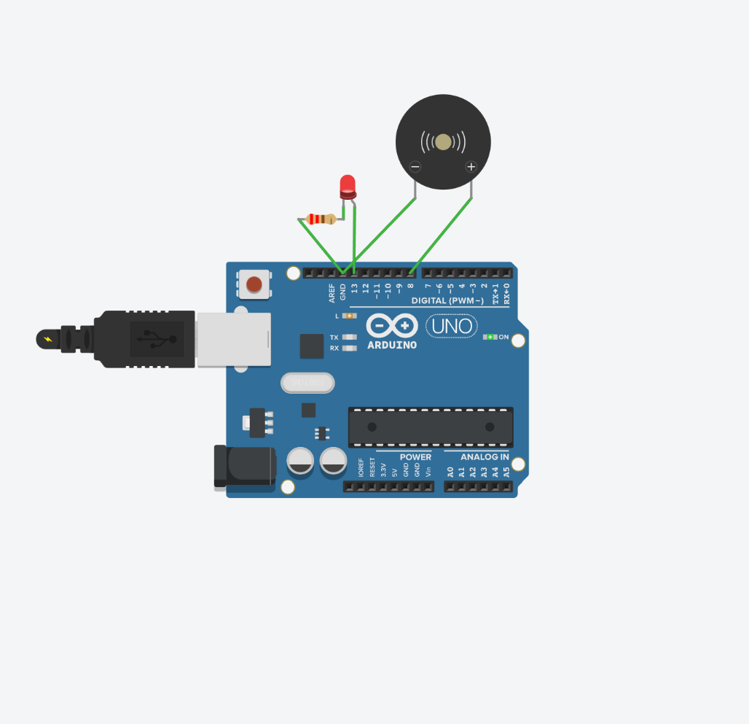
Figure A. 1 - Tinkercad Circuit Layout

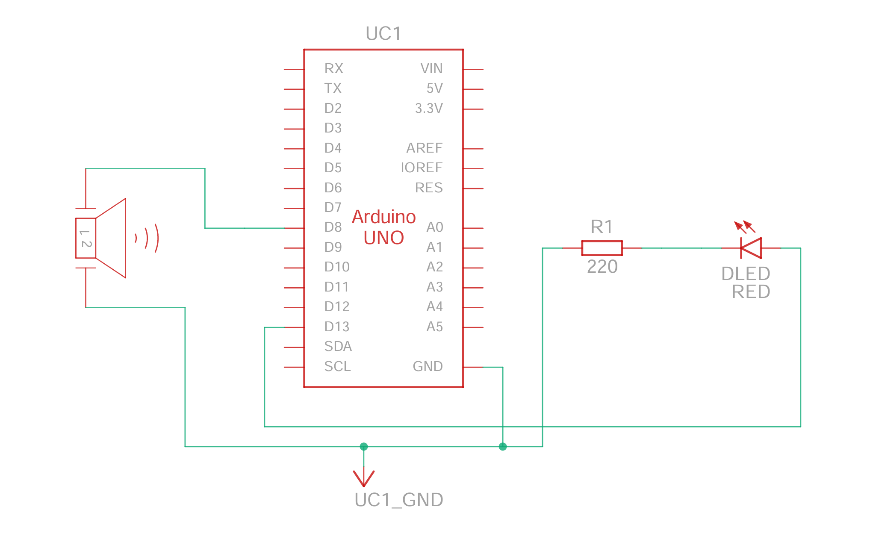
Figure A. 2 - Circuit Schematic Diagram

A.4 Arduino Command Mode Implementation
The Arduino was programmed to operate in command mode, receiving instructions via Serial communication.

Arduino Code (Simulation Tested)
int ledPin = 13;
int buzzerPin = 8;
void setup() {
pinMode(ledPin, OUTPUT);
pinMode(buzzerPin, OUTPUT);
Serial.begin(9600);
}
void loop() {
if (Serial.available() > 0) {
char data = Serial.read();
if (data == '1') {
digitalWrite(ledPin, HIGH);
digitalWrite(buzzerPin, HIGH);
}
else if (data == '0') {
digitalWrite(ledPin, LOW);
digitalWrite(buzzerPin, LOW);
}
}
}

A.5 Simulation Testing Procedure
- Circuit was assembled in Tinkercad Circuits
- Code was uploaded within the simulation editor
- Serial Monitor was used to send commands:
  - '1' → Activate LED and buzzer
  - '0' → Deactivate system

A.6 Observed Results
Input Command | System Response
1 | LED ON + Buzzer ON
0 | LED OFF + Buzzer OFF

A.7 Key Learnings from Simulation
- Validated correct wiring and component behaviour
- Confirmed Serial communication logic
- Understood pin-level hardware control
- Identified common issues (LED polarity, resistor placement)
- Built confidence before real hardware deployment

A.8 Limitations of Simulation
- No real-time integration with Python (serial communication unsupported)
- No physical latency or noise factors
- Limited to virtual environment constraints

A.9 Conclusion
The simulation phase successfully ensured that the hardware logic is functionally correct and integration-ready.
This approach reduced risk and ensured that once physical hardware is introduced, the system can transition smoothly without fundamental changes.

Day 5 – Real Arduino Hardware Integration

1. Project Status Overview
On Day 5, the VisionGuard project successfully moved from software simulation to real hardware integration. Until Day 4, the Arduino alert layer was simulated using Python print statements. Today, that simulated layer was replaced with an actual Arduino Uno R3, connected to a real LED and buzzer alert circuit.
This marks a major transition:
AI Detection System → Python Serial Communication → Arduino Uno → LED + Buzzer Alert
The system is now no longer only a computer vision project. It has become a real AI + Embedded Systems project.

2. Work Completed Today

2.1 Arduino IDE Setup
The Arduino IDE was successfully installed and configured.
Completed tasks:
Arduino Uno R3 connected to laptop
Correct board selected: Arduino Uno
Correct COM port detected
Arduino IDE ready for upload
This confirmed that the laptop could communicate with the Arduino board.

2.2 Blink Test Verification
A basic blink test was uploaded to the Arduino Uno to verify that the board was functioning correctly.

Blink Test Code
void setup() {
pinMode(13, OUTPUT); // Pin 13 controls the onboard LED
}
void loop() {
digitalWrite(13, HIGH); // LED ON
delay(1000); // Wait 1 second
digitalWrite(13, LOW); // LED OFF
delay(1000); // Wait 1 second
}

Result
Arduino onboard LED blinked successfully.
This confirmed that code upload and board execution were working properly.

3. LED and Buzzer Hardware Setup
Today, the external hardware alert circuit was built using:
Arduino Uno R3
LED
220Ω resistor
Active buzzer
Breadboard
Jumper wires
USB cable

3.1 LED Wiring
Arduino Pin 13 → LED long leg/anode
LED short leg/cathode → 220Ω resistor → Arduino GND

3.2 Buzzer Wiring
Arduino Pin 8 → Buzzer positive terminal
Buzzer negative terminal → Arduino GND

3.3 Hardware Test Code
int ledPin = 13;
int buzzerPin = 8;
void setup() {
pinMode(ledPin, OUTPUT);
pinMode(buzzerPin, OUTPUT);
}
void loop() {
digitalWrite(ledPin, HIGH);
digitalWrite(buzzerPin, HIGH);
delay(1000);
digitalWrite(ledPin, LOW);
digitalWrite(buzzerPin, LOW);
delay(1000);
}

3.4 Result
External LED and buzzer both worked successfully.
This verified that the circuit wiring was correct and that Arduino could control physical alert devices.
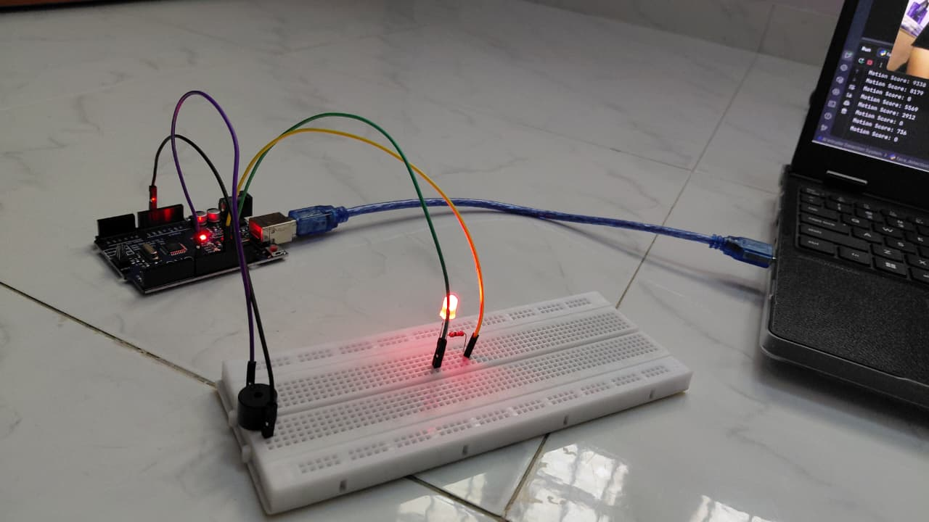
Figure 5. 1 - Prototype Circuit Connection – Arduino Uno with LED and Buzzer
The prototype circuit shows the Arduino Uno R3 connected with an external LED and active buzzer. Digital pin 13 controls the LED through a 220Ω resistor, while digital pin 8 controls the buzzer. Both components share a common GND connection with the Arduino.

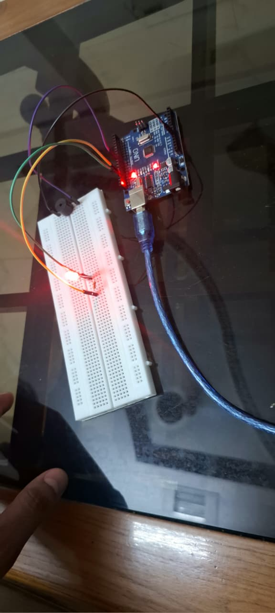
Figure 5. 2 - Top View

4. Arduino Command Mode Implementation
After verifying the hardware, the Arduino was converted from automatic blinking mode to command mode.
In command mode, Arduino waits for serial commands:
'1' → Turn LED and buzzer ON
'0' → Turn LED and buzzer OFF

Arduino Command Mode Code
int ledPin = 13;
int buzzerPin = 8;
void setup() {
pinMode(ledPin, OUTPUT);
pinMode(buzzerPin, OUTPUT);
Serial.begin(9600);
}
void loop() {
if (Serial.available() > 0) {
char data = Serial.read();
if (data == '1') {
digitalWrite(ledPin, HIGH);
digitalWrite(buzzerPin, HIGH);
}
else if (data == '0') {
digitalWrite(ledPin, LOW);
digitalWrite(buzzerPin, LOW);
}
}
}

Serial Monitor Testing
Commands were sent manually using the Arduino IDE Serial Monitor:
Input: 1
Output: LED ON + Buzzer ON
Input: 0
Output: LED OFF + Buzzer OFF

Result
Arduino command mode worked successfully.
This confirmed that Arduino could respond to external commands.

5. Python to Arduino Serial Communication
After Arduino command mode was verified, Python serial communication was tested using the pyserial library.

Python Serial Test Code
import serial
import time
# Change COM3 to the actual Arduino COM port
arduino = serial.Serial('COM3', 9600)
time.sleep(2)
while True:
command = input("Enter 1 for ON, 0 for OFF, q to quit: ")
if command == "q":
arduino.write(b'0')
print("Exiting... Arduino OFF")
break
if command in ["1", "0"]:
arduino.write(command.encode())
print(f"Sent command: {command}")
else:
print("Invalid input. Use 1, 0, or q.")
arduino.close()

Result
Python successfully controlled Arduino.
Test results:
Python input 1 → LED and buzzer ON
Python input 0 → LED and buzzer OFF
This completed the bridge between laptop software and Arduino hardware.

6. VisionGuard Hardware Integration
The simulated Arduino function was replaced with real Arduino serial communication.

Arduino Serial Initialization
import serial
arduino = serial.Serial("COM3", 9600)
time.sleep(2)
The current VisionGuard code initializes Arduino using serial.Serial("COM3", 9600) and waits briefly before communication begins.

Real Arduino Communication Function
def send_to_arduino(signal):
if signal == 1:
arduino.write(b'1')
print("🔴 Arduino Alert ON")
print("🔴 LED ON | 🔔 BUZZER ON")
else:
arduino.write(b'0')
print("🟢 Arduino Alert OFF")
print("🟢 SYSTEM OFF")
This function sends real serial commands to the Arduino. A signal of 1 turns the alert system ON, and a signal of 0 turns it OFF.

7. Final VisionGuard Alert Logic
The core VisionGuard logic now uses:
Motion detection
Face detection
Motion memory
State-based Arduino control
Cooldown image saving

System Variables
image_count = 0
last_capture_time = 0
cooldown = 5
system_active = False
last_motion_time = 0
motion_hold_time = 2
The system_active variable prevents repeated ON/OFF triggering every frame. The motion memory variables allow the system to remember motion for a short duration, solving the issue where fast movement caused face detection and motion detection to miss each other in the same frame.

8. Motion Memory Enhancement
A practical issue was observed:
When the user moved fast and then became still, the buzzer sometimes did not ring.

Root Cause
The system originally required:
motion_detected == True AND face_detected == True
in the exact same frame.
But during fast movement:
Motion detected → face may blur
Face detected → motion may already become false
So, the alert did not always trigger.

Motion Memory Solution
motion_detected = motion_score > 7000
if motion_detected:
last_motion_time = time.time()
recent_motion = (time.time() - last_motion_time) < motion_hold_time
This allows motion to remain valid for a short time after it is detected. The current system calculates motion score using frame differencing and then determines whether significant motion occurred.

Updated Alert Condition
if recent_motion and len(faces) > 0:
Instead of requiring motion and face detection in the same instant, the system now checks:
Recent motion + face detected = alert
This makes the system more stable and realistic.

9. State-Based Arduino Alert Handling
The project uses state-based logic instead of simple time-based ON/OFF control.

Final Alert Logic
current_time = time.time()
if recent_motion and len(faces) > 0:
if not system_active:
print("Intruder Detected!")
send_to_arduino(1)
system_active = True
if current_time - last_capture_time > cooldown:
filename = f"captures/intruder_{image_count}.jpg"
cv2.imwrite(filename, frame)
image_count += 1
last_capture_time = current_time
else:
if system_active:
send_to_arduino(0)
system_active = False
The existing uploaded version already uses state-based handling with system_active, where Arduino turns ON when an intruder appears and turns OFF only when the intruder condition ends.

Why This Is Important
Earlier behavior:
Alert ON → wait → Alert OFF
Improved behavior:
Intruder present → Alert stays ON
Intruder gone → Alert turns OFF
This is closer to how a real security system behaves.

10. System Cleanup
At program termination, the system safely releases hardware and software resources.

Cleanup Code
cap.release()
cv2.destroyAllWindows()
send_to_arduino(0)
arduino.close()
This ensures:
Camera is released
OpenCV windows are closed
Arduino alert is turned OFF
Serial port is closed safely
The current code includes cleanup steps for the webcam, display window, Arduino OFF signal, and serial connection close.

11. Final Day 5 System Workflow
1. Webcam captures live video
2. Motion detection checks scene activity
3. Face detection confirms human presence
4. Motion memory stabilizes fast movement cases
5. If recent motion + face detected:
Arduino receives '1'
LED turns ON
Buzzer turns ON
Image is saved with cooldown
6. If intruder condition ends:
Arduino receives '0'
LED turns OFF
Buzzer turns OFF

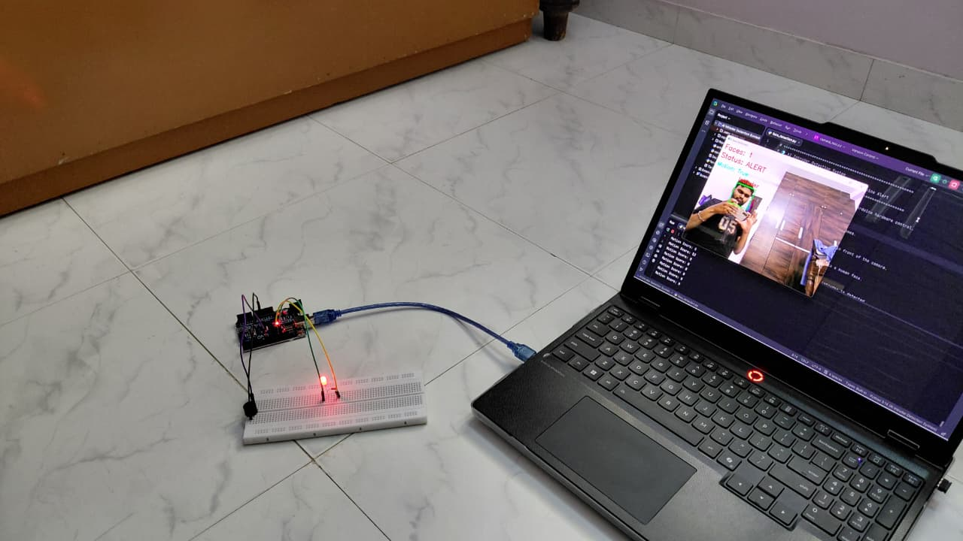
Figure 5. 3 - Arduino Alert Circuit with Real-Time Intruder Detection Output

12. Final Behavior Table
Scenario | System Response
No motion | Safe, no alert
Motion only | No Arduino trigger
Face only without recent motion | No alert
Fast motion followed by face detection | Alert triggers due to motion memory
Recent motion + face | LED ON + buzzer ON
Intruder leaves | LED OFF + buzzer OFF
Program closes | Arduino OFF + serial closed

13. Key Achievements of Day 5
Arduino IDE setup completed
Arduino Uno detected successfully
Blink test uploaded and verified
External LED and buzzer connected
LED and buzzer hardware tested
Arduino command mode implemented
Serial Monitor command testing completed
Python controlled Arduino successfully
VisionGuard integrated with real Arduino
Motion memory issue identified and solved
State-based hardware alert logic stabilized

14. Next Development Roadmap
Recommended next enhancements:
1. Add motion area visualization
2. Improve face detection robustness
3. Add authorized vs unauthorized face recognition
4. Add ESP32 Wi-Fi alert system
5. Add Telegram or email notification
6. Add final project architecture diagram
7. Prepare GitHub repository and README

Day 6 – System Stabilization, Visualization, and Documentation

1. Project Status Overview
Day 6 focused on improving the overall quality, presentation, and organization of the VisionGuard Phase 1 system. After completing real Arduino hardware integration on Day 5, today’s work was centered on system validation, visual enhancement, documentation improvement, and preparing the project for professional presentation.
The main goal was to make the project not only functional, but also clean, demonstrable, and report-ready.

2. Full System Re-Test
A complete end-to-end test was performed to verify that all major modules are working together correctly.

Tested Workflow
Webcam Input
→ Motion Detection
→ Face Detection
→ Decision Logic
→ Python Serial Communication
→ Arduino Uno
→ LED + Buzzer Alert

Test Scenarios
Test Case | Expected Result | Status
No motion | No alert | Passed
Motion only | No alert | Passed
Face only | No alert | Passed
Motion + face | LED and buzzer ON | Passed
Intruder leaves | LED and buzzer OFF | Passed

Result
The complete VisionGuard Phase 1 system was successfully re-tested. The AI detection logic, Arduino communication, LED alert, and buzzer alert worked as expected.

3. Motion Area Visualization Added
A new visual enhancement was added to display the movement area on the live video feed.
Earlier, the system only displayed:
Faces count
Motion status
SAFE / ALERT status
Face bounding box
Today, the system was upgraded to show a motion bounding box around the detected moving region.

Motion Visualization Code
# Find moving areas from threshold image
contours, _ = cv2.findContours(
thresh,
cv2.RETR_EXTERNAL,
cv2.CHAIN_APPROX_SIMPLE
)
# Draw only the largest motion area to avoid too many boxes
if contours:
largest_contour = max(contours, key=cv2.contourArea)
if cv2.contourArea(largest_contour) > 3000:
x, y, w, h = cv2.boundingRect(largest_contour)
cv2.rectangle(
frame,
(x, y),
(x + w, y + h),
(255, 0, 0),
2
)
cv2.putText(
frame,
"Motion",
(x, y - 10),
cv2.FONT_HERSHEY_SIMPLEX,
0.6,
(255, 0, 0),
2
)

Improvement Made
Initially, too many motion boxes appeared due to small noise regions being detected as separate contours. To solve this, the logic was improved to display only the largest meaningful motion area.
This made the visual output cleaner and more suitable for demonstration.

4. Prototype Photo Placement in Report
The hardware prototype photo was added to the Day 5 technical report in the correct section.

Placement
Day 5 Report
→ Section 3: LED and Buzzer Hardware Setup
→ After 3.1 LED Wiring and 3.2 Buzzer Wiring
→ Before 3.3 Hardware Test Code

Caption Used
Figure 5.1: Prototype Circuit Connection – Arduino Uno with LED and Buzzer

Additional Demo Photo Caption
For the photo showing both the circuit and the intruder detection output, the following caption was prepared:
Figure 5.2: VisionGuard Prototype Demonstration – Arduino Alert Circuit with Real-Time Intruder Detection Output

Description
The figure shows the complete VisionGuard prototype during testing. The Arduino Uno R3 hardware circuit with LED and buzzer is connected to the Python-based AI intruder detection system. When motion and face detection conditions are satisfied, the system triggers the physical alert and displays the real-time detection output on screen.
This improved the technical report by adding visual proof of hardware implementation and system testing.

5. Project Folder Cleanup
The project directory was organized into a clean professional structure for future GitHub upload and report submission.

Final Folder Structure
VisionGuard/
│
├── code/
│ ├── visionguard_main.py
│ └── arduino_test.py
│
├── arduino/
│ ├── command_mode.ino
│ └── led_buzzer_test.ino
│
├── captures/
│ ├── sample_intruder_capture.jpg
│
├── docs/
│ ├── Day_5_Technical_Report.docx
│ └── VisionGuard_Report.docx
│
├── images/
│ ├── prototype_circuit.jpg
│ ├── complete_demo.jpg
│ ├── tinkercad_circuit.png
│ └── phase_1_architecture.png
│
├── README.md
├── requirements.txt
└── .gitignore

Purpose of Cleanup
The cleanup ensures:
Python code is separated from Arduino code
Reports are stored in documentation folder
Images and prototype photos are organized
Captured evidence images are separated
GitHub upload becomes easier
Project looks professional and understandable

6. README Draft Completed
A basic README.md file was created for the VisionGuard project.

README Content Includes
Project title
Short project description
Features
Hardware used
Software used
System workflow
Output behavior
Future scope

README Draft
# VisionGuard – AI Intruder Detection System
VisionGuard is an AI + Embedded Systems project that detects intruders using real-time motion detection and face detection. When an intruder is detected, Python sends a serial command to Arduino Uno, which triggers an LED and buzzer alert.
## Features
- Real-time webcam monitoring
- Motion detection using frame differencing
- Face detection using OpenCV Haar Cascade
- Motion memory for stable detection
- Arduino Uno LED and buzzer alert
- Cooldown-based image capture
- Real-time status display
- Motion area visualization
## Hardware Used
- Arduino Uno R3
- LED
- 220Ω resistor
- Active buzzer
- Breadboard
- Jumper wires
- Laptop webcam
## Software Used
- Python
- OpenCV
- PySerial
- Arduino IDE
## System Workflow
Camera → Motion Detection → Face Detection → Decision Logic → Python Serial Communication → Arduino Alert
## Output
When motion and face detection conditions are satisfied:
- LED turns ON
- Buzzer turns ON
- Intruder image is saved in the captures folder
- System status changes to ALERT
## Future Scope
- ESP32 WiFi alert system
- Telegram or email notifications
- Authorized vs unauthorized face recognition
- Cloud storage for captured images

7. Day 6 Key Achievements
Full VisionGuard system re-tested successfully
Motion area visualization added
Multiple motion boxes issue solved
Prototype circuit photo placement completed
Complete demo photo caption prepared
Project folder cleaned and organized
README draft completed
GitHub-ready structure planned

8. Technical Learning Outcomes
Day 6 helped strengthen skills in:
System testing
Visual debugging
Contour-based motion visualization
Project documentation
Report image placement
Folder organization
README writing
GitHub preparation
Professional project presentation

9. Development Conclusion
Day 6 transformed VisionGuard from a working prototype into a more polished and presentable engineering project.
The system now has:
Functional AI detection
Real Arduino hardware alert
Motion visualization
Organized documentation
Clean project structure
README file for presentation
This makes VisionGuard Phase 1 suitable for academic submission, GitHub upload, and portfolio presentation.

10. Next Development Roadmap
The next development steps are:
1. Final code cleanup
2. Prepare GitHub upload
3. Add requirements.txt and .gitignore
4. Improve README with images and architecture diagram
5. Begin Phase 2 using ESP32 for IoT-based alerts

Day 7 – Final Code Cleanup, Architecture Diagram, and GitHub Preparation

1. Project Status Overview
Day 7 focused on preparing VisionGuard Phase 1 for professional presentation and future upload. After completing the working AI + Arduino hardware system in earlier phases, today’s work emphasized final polishing, documentation readiness, project structure, and visual explanation of the system architecture.
The objective was to make the project easier to understand, easier to maintain, and ready for GitHub or academic submission.

2. Final Code Cleanup
The main VisionGuard code was reviewed and cleaned to improve readability and maintainability.

Cleanup Focus Areas
1. Removed unnecessary duplicate logic
2. Grouped related code sections together
3. Improved naming consistency
4. Organized imports properly
5. Ensured cleanup functions run safely at the end
6. Kept AI logic, Arduino logic, and UI logic clearly separated

Cleaned Code Structure
Import libraries
↓
Initialize Arduino communication
↓
Define Arduino control function
↓
Create captures folder
↓
Initialize variables
↓
Load face detection model
↓
Start webcam
↓
Run main loop
↓
Motion detection
↓
Face detection
↓
UI display
↓
Arduino alert logic
↓
Draw visualization
↓
Cleanup resources
This structure makes the program easier to debug and easier to explain during viva, interviews, or project review.

3. Comments Added Where Needed
Comments were added to explain important logic blocks, especially where beginners may find the code difficult.

Commented Areas
Arduino serial communication
Motion detection pipeline
Gaussian blur usage
Thresholding and dilation
Motion memory logic
Face detection
State-based alert system
Cooldown-based image saving
OpenCV display and exit condition
Final cleanup

Example: Motion Detection Comments
# Convert previous and current frames to grayscale
# Grayscale reduces processing load and simplifies comparison
prev_gray = cv2.cvtColor(prev_frame, cv2.COLOR_BGR2GRAY)
curr_gray = cv2.cvtColor(frame, cv2.COLOR_BGR2GRAY)
# Apply Gaussian blur to reduce camera noise and small lighting changes
prev_gray = cv2.GaussianBlur(prev_gray, (9, 9), 0)
curr_gray = cv2.GaussianBlur(curr_gray, (9, 9), 0)
# Compare previous and current frames to detect changes
diff = cv2.absdiff(prev_gray, curr_gray)
# Convert difference image into binary motion mask
_, thresh = cv2.threshold(diff, 40, 255, cv2.THRESH_BINARY)

Example: Arduino Control Comment
def send_to_arduino(signal):
# Send '1' to Arduino to turn ON LED and buzzer
# Send '0' to Arduino to turn OFF LED and buzzer
if signal == 1:
arduino.write(b'1')
print("Arduino Alert ON")
else:
arduino.write(b'0')
print("Arduino Alert OFF")
The comments improve the educational value of the code and help future revision.

4. Final Architecture Diagram Created
A final Phase 1 architecture diagram was created to visually explain the complete VisionGuard system.

Diagram Title
VisionGuard – Phase 1 Final Architecture

Diagram Subtitle
AI Intruder Detection System with Arduino Uno Hardware Alert

Diagram Includes
Webcam / laptop camera
Video frame capture using Python + OpenCV
AI detection engine
Motion detection
Face detection
Motion memory
Decision logic
Evidence capture
PySerial communication
Arduino Uno R3
LED alert
Active buzzer alert
On-screen UI/status display
System behavior summary

Architecture Flow
Webcam / Laptop Camera
→ Video Frame Capture
→ AI Detection Engine
→ Motion Detection
→ Face Detection
→ Motion Memory
→ Decision Logic
→ Evidence Capture
→ Serial Communication
→ Arduino Uno R3
→ LED Alert + Buzzer Alert

Purpose of the Diagram
The architecture diagram helps reviewers quickly understand how the software AI layer communicates with the embedded hardware layer. It also shows that VisionGuard is not only a Python project, but a complete AI + Electronics system.

5. GitHub Upload Structure Prepared
The project folder was prepared in a clean GitHub-ready format.

Final GitHub Folder Structure
VisionGuard/
│
├── code/
│ ├── visionguard_main.py
│ └── arduino_test.py
│
├── arduino/
│ ├── command_mode.ino
│ └── led_buzzer_test.ino
│
├── docs/
│ ├── technical_reports/
│ │ ├── Day_1_Report.docx
│ │ ├── Day_2_Report.docx
│ │ ├── Day_3_Report.docx
│ │ ├── Day_4_Report.docx
│ │ ├── Day_5_Report.docx
│ │ ├── Day_6_Report.docx
│ │ └── Day_7_Report.docx
│ │
│ └── architecture/
│ └── phase_1_architecture.png
│
├── images/
│ ├── prototype_circuit.jpg
│ ├── complete_demo.jpg
│ ├── tinkercad_circuit.png
│ └── wiring_diagram.png
│
├── captures/
│ └── sample_intruder_capture.jpg
│
├── requirements.txt
├── README.md
├── .gitignore
└── LICENSE
This structure separates source code, Arduino code, documentation, images, captured samples, and setup files.

6. Supporting Files Prepared

requirements.txt
A requirements.txt file was planned for Python dependencies.
opencv-python
pyserial
numpy
This allows anyone to install required libraries easily using:
pip install -r requirements.txt

.gitignore
A .gitignore file was planned to keep unnecessary files out of GitHub.
__pycache__/
*.pyc
.venv/
env/
captures/intruder_*.jpg
.DS_Store
This prevents temporary files, virtual environments, and multiple captured intruder images from being uploaded.

README.md
The README file was prepared to include:
Project title
Short description
Features
Hardware used
Software used
System workflow
Folder structure
How to run
Arduino setup
Future scope
The README will act as the first explanation page for anyone viewing the project.

7. Next Development Roadmap
The next phase will move VisionGuard toward IoT capability using ESP32.
Phase 2: ESP32 IoT Alert System
1. Connect ESP32 with LED and buzzer
2. Test ESP32 serial/Wi-Fi control
3. Add Telegram or email alert
4. Build remote notification workflow

Day 8 – GitHub Repository Finalization and Phase 1 Closure

1. Project Status Overview
Day 8 focused on finalizing the GitHub repository and officially closing VisionGuard Phase 1.
After Day 7 prepared the folder structure, documentation, architecture diagram, and GitHub-ready files, Day 8 involved uploading the project, improving the repository presentation, adding visual elements to the README, confirming clone/download readiness, and preparing the roadmap for Phase 2 using ESP32.
This day marked the transition from:
Local Project Folder
to:
Public GitHub Portfolio Project

2. GitHub Repository Created
A new GitHub repository was created for the VisionGuard project.

Repository Name
VisionGuard

Repository Description
AI-powered intruder detection system using Python, OpenCV, and Arduino Uno. It detects motion and faces in real time, triggers LED/buzzer hardware alerts via serial communication, saves evidence images, and includes motion visualization and cooldown-based alert control.
The description clearly summarizes the project’s purpose, technologies, and core functionality within a professional GitHub format.

3. Project Uploaded to GitHub
The complete VisionGuard Phase 1 project folder was uploaded to GitHub.

Uploaded Content
Python source code
Arduino sketches
Technical reports
Architecture diagram
Prototype circuit photos
Complete demo photos
README.md
requirements.txt
.gitignore
Sample capture image
Phase 2 roadmap

Repository Verification Checklist
The GitHub repository was checked to confirm:
README visible on main page
code/ folder uploaded
arduino/ folder uploaded
docs/ folder uploaded
images/ folder uploaded
captures/ folder uploaded with sample image
requirements.txt present
.gitignore present
architecture diagram visible
prototype images opening correctly

Result
GitHub repository verified successfully.

4. README Improved with Images
The README file was upgraded by adding visual sections for better presentation.

Added README Sections
## Phase 1 Architecture
![Phase 1 Architecture](images/phase_1_architecture.png)
## Hardware Prototype
![Prototype Circuit](images/prototype_circuit.jpg)
## Working Demo
![Complete Demo](images/complete_demo.jpg)

Purpose of Adding Images
The images make the repository more visually understandable and professional.
They help viewers immediately understand:
System architecture
Arduino hardware setup
Real working prototype
AI detection output
This improves the first impression of the GitHub project.

5. Phase 1 Completion Status Added
A dedicated Phase 1 completion section was added to the README.

Added Section
## Phase 1 Status
Phase 1 of VisionGuard has been completed successfully. The system detects motion and faces using Python and OpenCV, sends serial commands to Arduino Uno, and triggers LED and buzzer hardware alerts in real time.
Current Phase 1 capabilities:
- Real-time motion detection
- Face detection using OpenCV
- Motion memory for stable alerts
- Arduino Uno LED and buzzer control
- Evidence image capture with cooldown
- Motion visualization on video feed

Importance
This section clearly communicates that Phase 1 is complete and functional. It also separates the current working system from future planned improvements.

6. Clone / Download Readiness Checked
The repository was reviewed from the perspective of a new user who wants to download and run the project.

Checked Items
requirements.txt exists
Arduino code exists
Main Python code exists
COM port instruction is mentioned
Arduino setup instructions are clear
Run command is mentioned
Exit key instruction is present

README Sections Checked
## Installation
pip install -r requirements.txt
## Arduino Setup
1. Upload arduino/command_mode.ino to Arduino Uno.
2. Connect LED to pin 13.
3. Connect active buzzer to pin 8.
4. Select correct COM port in Arduino IDE.
## Run the Project
1. Connect Arduino Uno to laptop.
2. Close Arduino Serial Monitor.
3. Open code/visionguard_main.py.
4. Change COM port if needed.
5. Run the Python script.
6. Press q to exit.

Result
Repository clone/download readiness checked successfully.
This ensures that another person can understand and run the project without needing direct explanation.

7. Phase 2 ESP32 Roadmap Added
A Phase 2 roadmap was prepared and added to the repository.

File Created
docs/Phase_2_Roadmap.md

Phase 2 Title
# VisionGuard Phase 2 Roadmap – ESP32 IoT Alert System

Phase 2 Goal
Upgrade VisionGuard from local Arduino-based alerting to an ESP32-based IoT alert system with WiFi-enabled remote notification capability.

Planned Phase 2 Tasks
ESP32 setup
ESP32 LED + buzzer test
WiFi connection test
Python to ESP32 communication
Remote alert system
Future expansion

Roadmap Content
# VisionGuard Phase 2 Roadmap – ESP32 IoT Alert System
## Goal
Upgrade VisionGuard from local Arduino-based alerting to an ESP32-based IoT alert system with WiFi-enabled remote notification capability.
## Phase 2 Tasks
### 1. ESP32 Setup
- Install ESP32 board support in Arduino IDE
- Select correct ESP32 board and COM port
- Upload blink test code
### 2. ESP32 LED + Buzzer Test
- Connect LED and active buzzer to ESP32
- Test GPIO-based alert control
### 3. WiFi Connection Test
- Connect ESP32 to local WiFi
- Print connection status and IP address on Serial Monitor
### 4. Python to ESP32 Communication
- Send alert signal from Python to ESP32
- Test serial or WiFi-based command control
### 5. Remote Alert System
- Add Telegram or email notification
- Send alert message when intruder is detected
### 6. Future Expansion
- Web dashboard
- Cloud image storage
- Authorized vs unauthorized face recognition

8. GitHub Website Workflow Used
The repository updates were made directly using the GitHub website.

Workflow Used
Open repository
Select file to edit
Click pencil/edit icon
Make changes
Scroll to Commit changes
Write commit message
Commit directly to main branch
For creating a new roadmap file:
Add file
→ Create new file
→ docs/Phase_2_Roadmap.md
→ Paste roadmap content
→ Commit changes
This was useful because changes could be made directly without needing local Git commands.

9. Phase 1 Final Status
VisionGuard Phase 1 is now complete.

Completed Phase 1 System
Laptop camera
→ Python OpenCV motion detection
→ Face detection
→ Motion memory
→ Decision logic
→ PySerial communication
→ Arduino Uno R3
→ LED + buzzer hardware alert
→ Evidence image capture
→ Motion visualization

Current Capabilities
Real-time webcam monitoring
Motion detection
Face detection
Motion memory for stable triggering
Arduino Uno serial communication
LED and buzzer alert
Evidence capture with cooldown
Motion area visualization
Professional documentation
GitHub-ready repository

